AIE 425 Intelligent Recommender Systems, Fall Semester 24/25

Assignment #3: Covariance and Matrix Factorization

Student ID: A20000847

Full Name: Mohamed Yasser Saad Ahmed

Introduction
Handling missing ratings is a significant challenge in developing efficient and accurate recommender systems. The absence of data can hinder the ability to deliver reliable predictions and personalized recommendations. This project explores the impact of various computational techniques, including covariance matrix analysis, matrix factorization, and Singular Value Decomposition (SVD), on addressing this issue.
The covariance matrix serves as a foundation for understanding the relationships between users or items by capturing their dependencies. This approach enables the identification of patterns and correlations, which are essential for predicting missing ratings and determining the closest peers in a dataset. While computationally simple, covariance-based methods can struggle with scalability and sparsity in large datasets.
Matrix factorization techniques, on the other hand, have revolutionized the field by decomposing the rating matrix into latent factors that capture hidden relationships between users and items. Singular Value Decomposition (SVD), a powerful matrix factorization method, allows for dimensionality reduction, which enhances computational efficiency and prediction accuracy. These techniques excel at uncovering meaningful patterns, predicting missing ratings with high precision, and identifying the closest peers for users or items.
This project report investigates the practical application and comparison of these methods in tackling missing ratings. By analyzing their strengths and limitations, the study highlights their impact on improving recommendation quality and addressing the challenges of sparsity and scalability in real-world datasets.



Implementation, Comparisons and Summary

First, we computed the covariance matrix between the items:
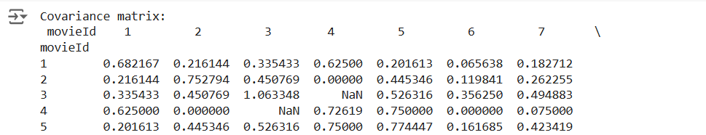
And then we used the reconstructed ratings matrix based on covariance to get the top 5 and 10 peers to make the predictions upon them:
The predicted ratings were as following: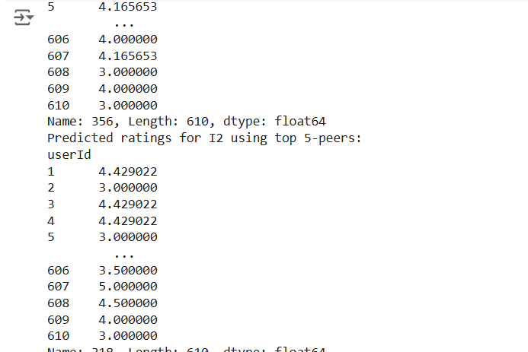
Then we took another approach using the maximum likelihood estimation and the results were as following:
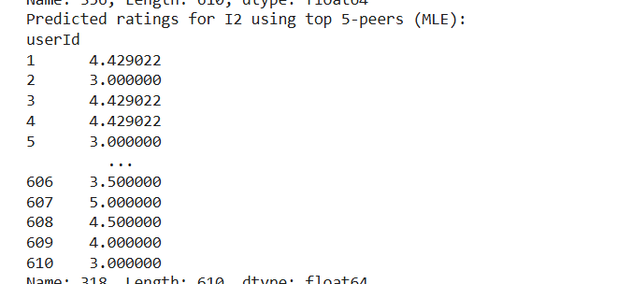
In the next section we implemented the singular value decomposition to decompose the ratings matrix into three reduced metrices (U, Σ, Vt):
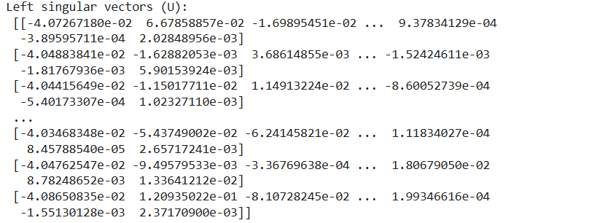
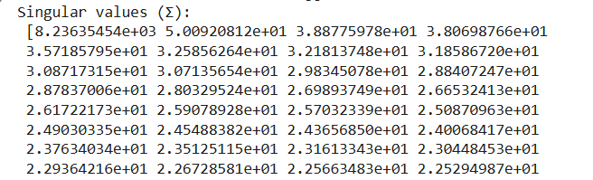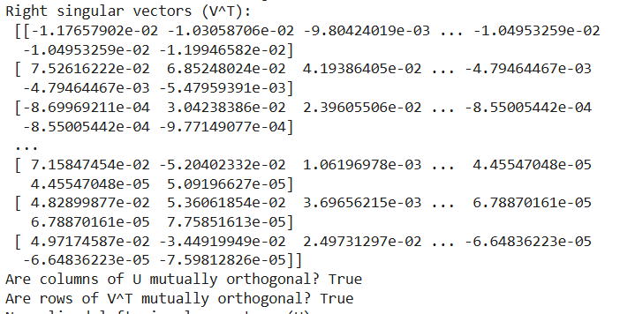
After calculating the eigenvalues and eigenvectors we made the predictions but unfortunately the results were not very impressive as the sparsity in the dataset was very high.

Conclusion
The project demonstrates the significant role that advanced techniques like covariance matrix analysis, matrix factorization, and Singular Value Decomposition (SVD) play in handling missing ratings within recommendation systems. These methods contribute to predicting missing ratings, identifying the closest peers for users or items, and improving the overall accuracy of recommendations. However, the high sparsity of the dataset presented a considerable challenge throughout the analysis.
The sparsity, characterized by a high number of NaN (missing) values in the dataset, severely impacted the accuracy and reliability of the calculations. Covariance-based methods, while straightforward and computationally efficient, struggled to capture meaningful relationships in such a sparse environment, leading to suboptimal predictions. Even advanced techniques like SVD and matrix factorization faced difficulties when dealing with the lack of sufficient data, as these methods depend heavily on the availability of underlying patterns to accurately decompose the rating matrix.
Despite these challenges, matrix factorization methods, particularly SVD, demonstrated resilience by leveraging latent features to approximate missing data and provide improved predictions. However, their performance was still limited by the sheer level of sparsity in the dataset, emphasizing the importance of addressing data quality in real-world applications.
In conclusion, while the methods employed in this project offer significant advancements in recommendation system design, the high sparsity of the dataset and the abundance of NaN values highlight the need for preprocessing strategies to mitigate data sparsity. Techniques such as imputation, hybrid models, or leveraging additional contextual data may be necessary to enhance the effectiveness of these approaches in future implementations.

